Al Powered Server Log Management Software

Increasing technology giving rise to errors and there is no automatic way to provide solution to generated error. Users always suffer from error and search solutions by sending queries to different servers and all servers will report some solutions and user has to identify correct solution from all those server responses which is very time consuming and difficult task.

To provide easiest solutions we are obtaining all servers logs with errors and then providing solution to all those server errors and then training all those error questions and possible solutions with Artificial Intelligence algorithm. Trained AI model can take user test error as input and then predict possible close solution to given error. With this AI model user has to search and get solution from single model and can avoid searching from different servers which can save time and reduce user burden.

So by using above AI trained model user will get solution from single one stop server without searching in different servers

You ask to get solution from online websites like BING, Google and other servers but all this server may not give accurate result and Google will give 100’s of results which is difficult to train and suggest close answer. So we have gather some possible questions and answers related to OS and programming and then use those questions and answers to train AI model.

If you want you can add new questions and answers to currently available dataset and you can add for other domains like OS errors, all programming errors and solutions and many more.

In below screen we are showing some errors/question and answers dataset details

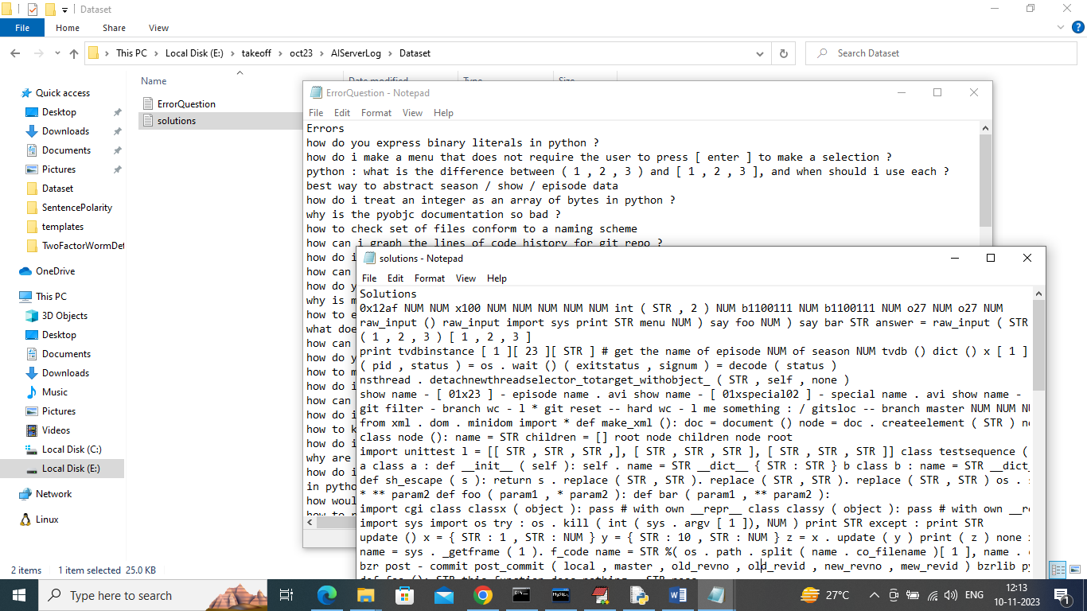

In above dataset folder we have errors and solution dataset and by using above datasets will train and test AI algorithm

To implement this project we have designed following modules

Admin Module: admin can login to web application by using username and password as ‘admin’ and ‘admin’ and then train AI model and make it ready to take user errors and to provide solutions. Admin can view list of registered users to track his website usage

User Module: user can sign up and login to system and then enter his error details to get solution.

To clean all questions text we have used NLP (Natural language tool kit API) like stemming, lemmatization and stop word removal and special symbol removal to make solution prediction accurate.

To run project first we need to create database by copying content from DB.txt file and paste in MYSQL

SCREEN SHOT

To run project double click on ‘run.bat’ file to start python DJANGO server and get below output

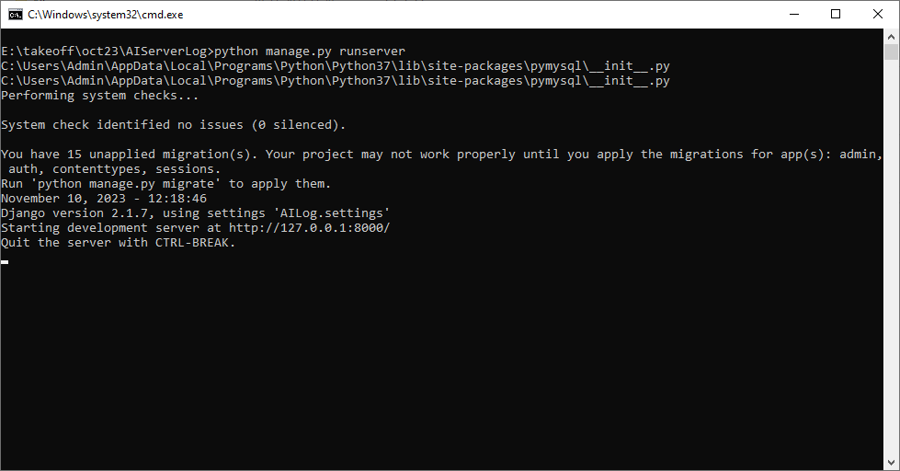

In above screen python server started and now open browser and enter URL as <http://127.0.0.1:8000/index.html> and press enter key to get below page

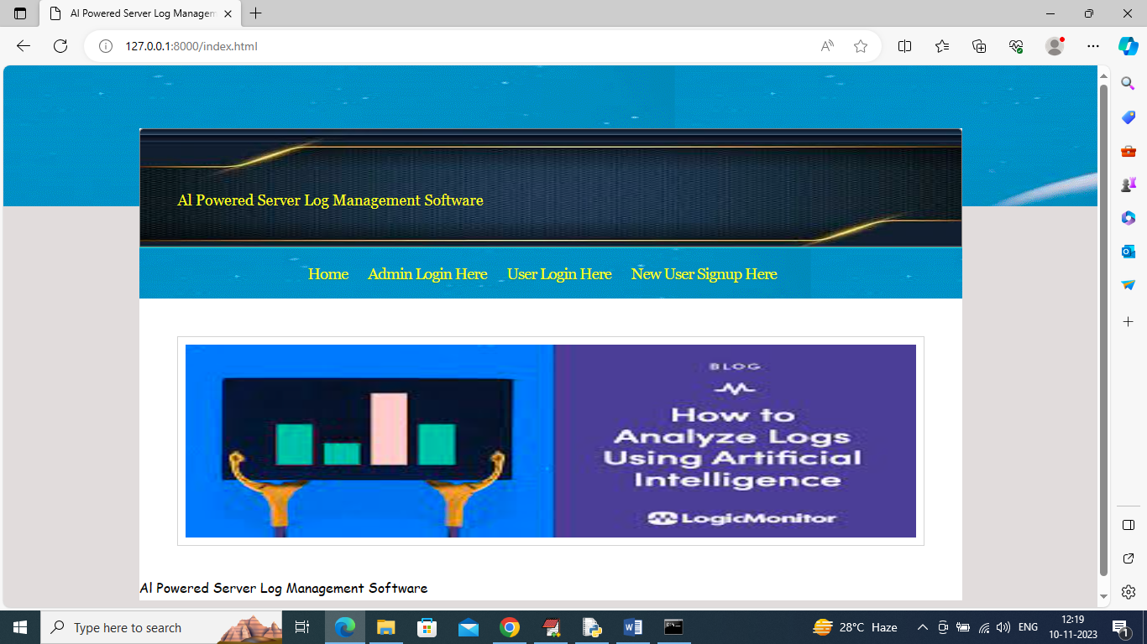

In above screen click on ‘Admin Login Here’ link to get below login page

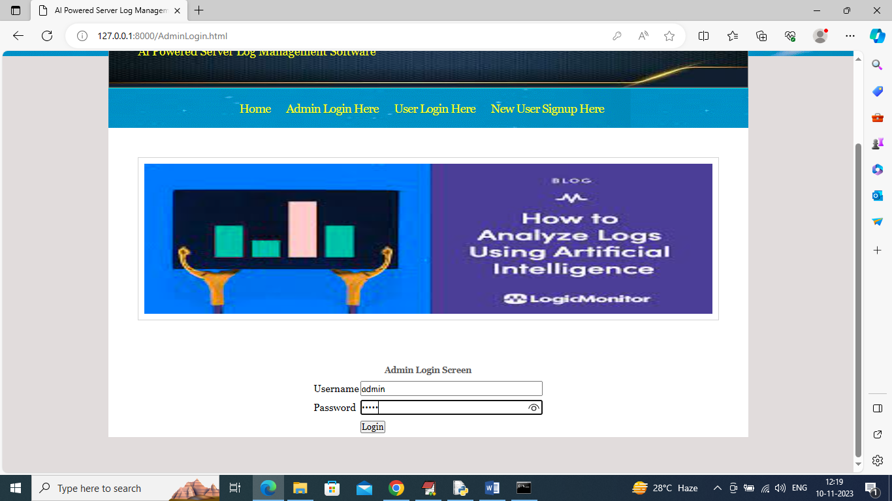

In above screen admin is login and after login will get below page

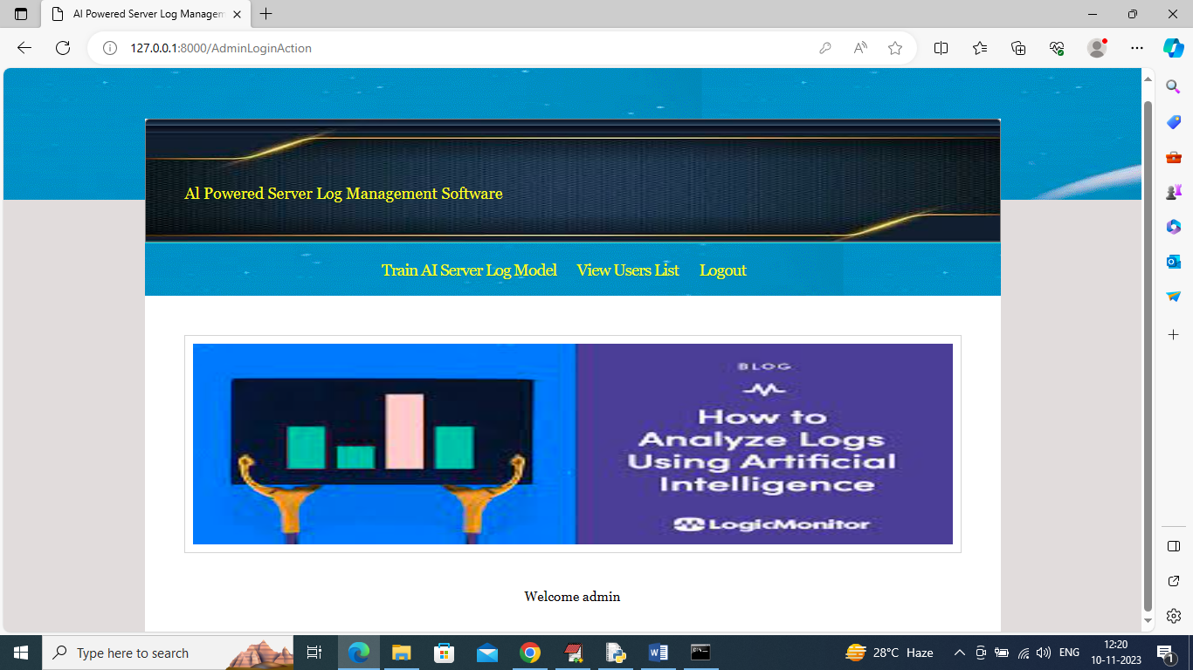

In above screen admin can click on ‘Train Server Log Model’ link to train AI model on dataset and then will get below output

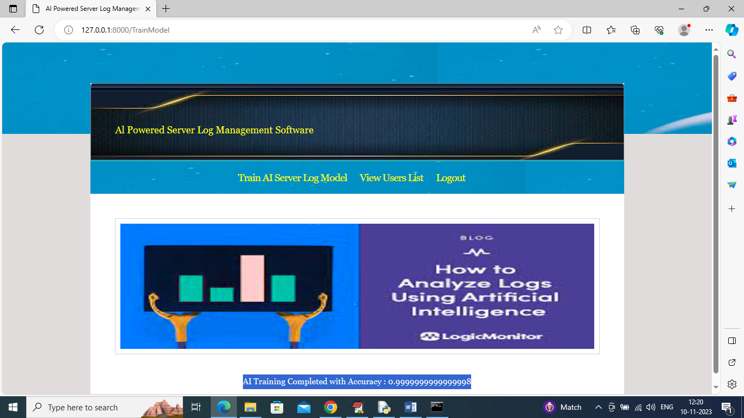

In above screen AI model training completed and its prediction accuracy is 0.99% and now click on ‘View Users List’ to get below page

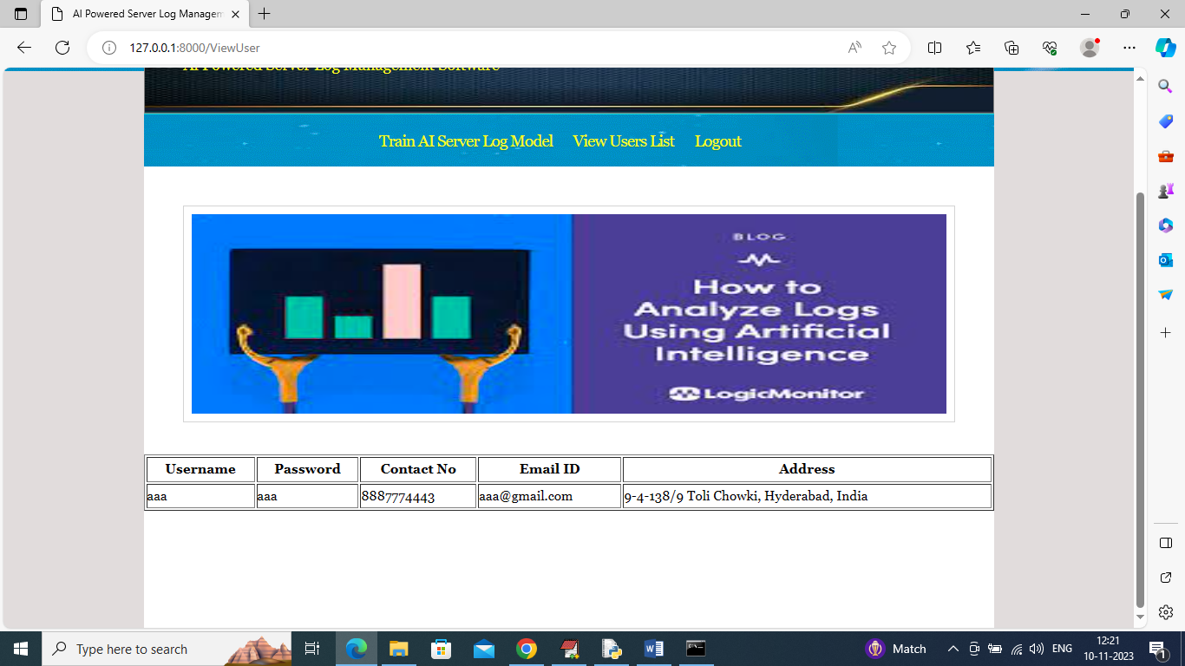

In above screen admin can view list of registered users and now logout and register one user to ask error from AI model

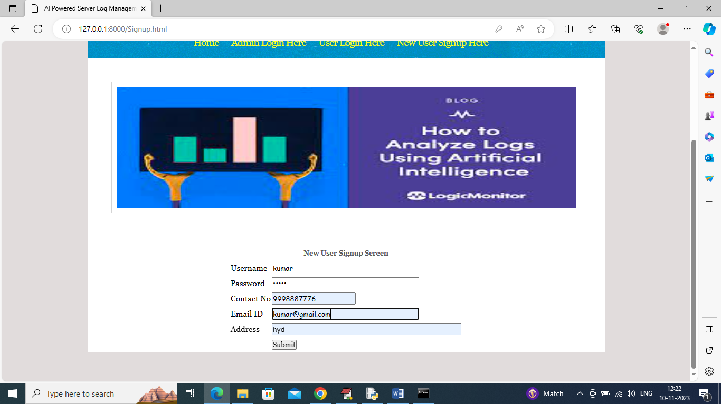

In above screen user is getting signup and then press button to get below page

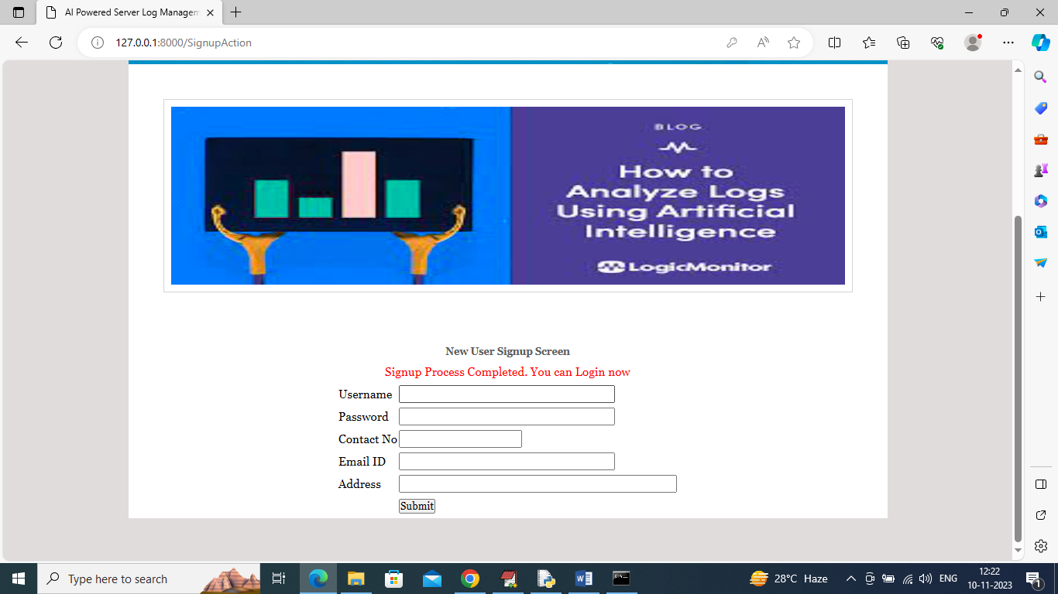

In above screen user signup completed and now click on ‘User Login Here’ link to get below page

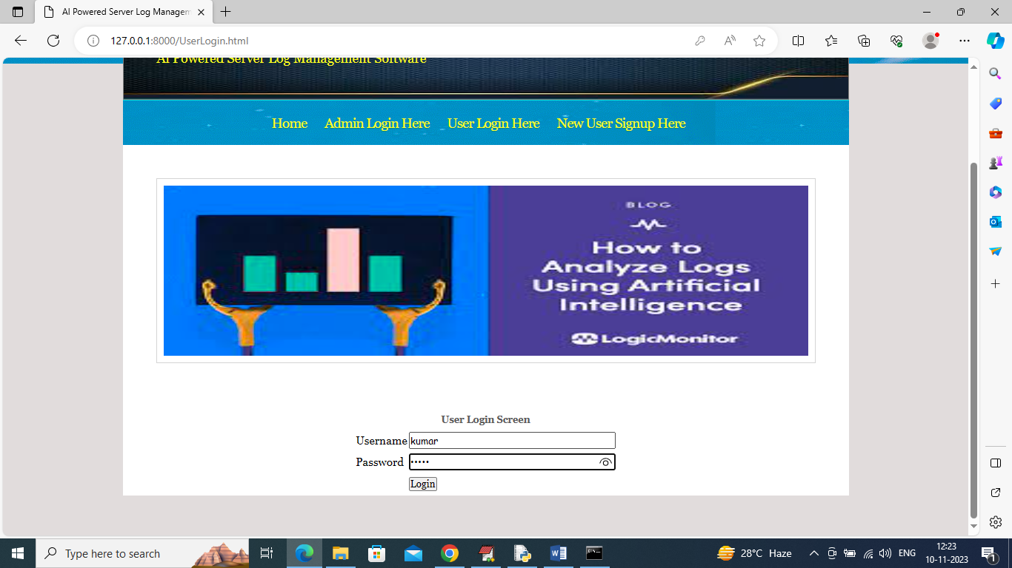

In above screen user is login and after login will get below page

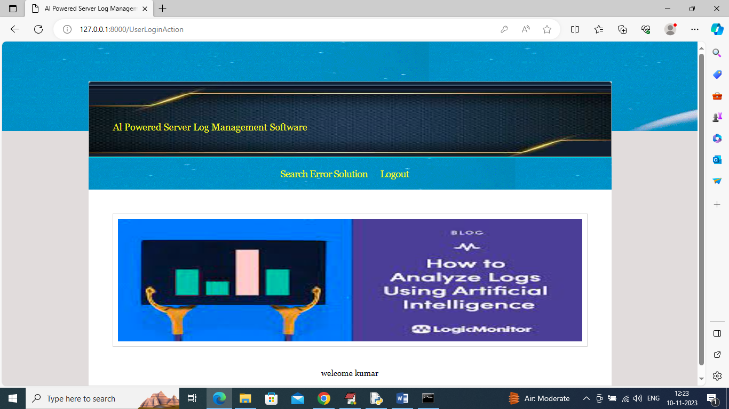

In above screen user can click on ‘Search Error Solution’ link to get below page

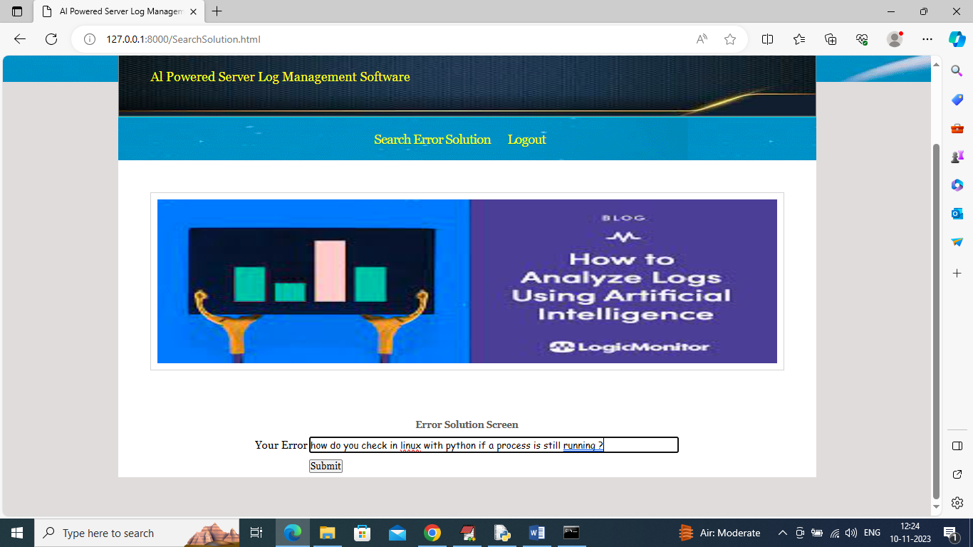

In above screen I entered some error query and then press button to get below output

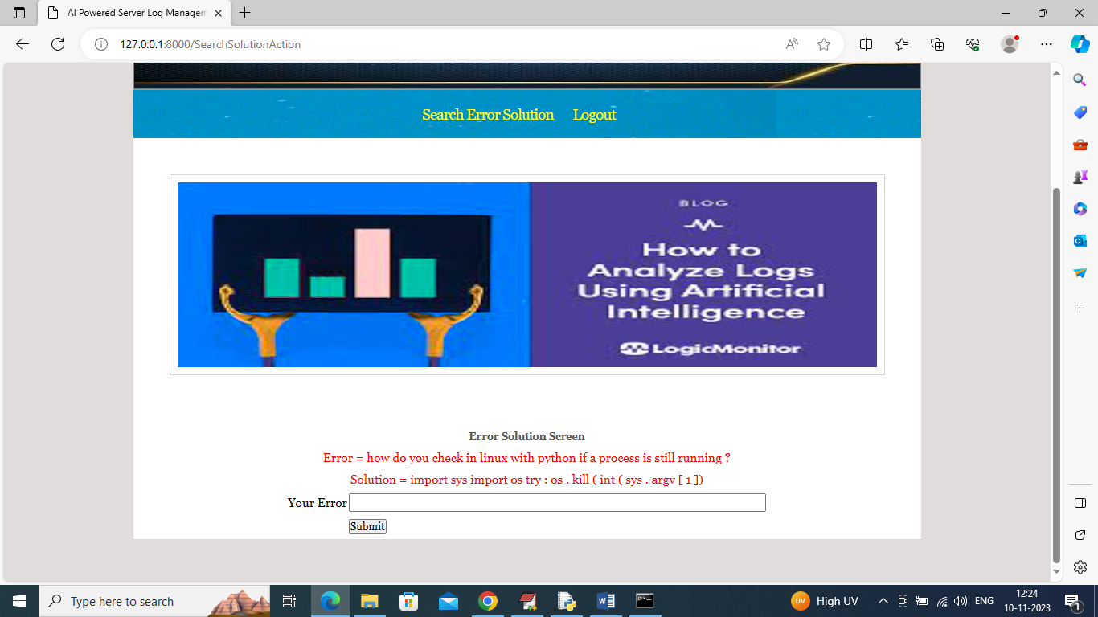

In above screen in red colour text can see Error question and its possible solution and similarly you can enter any question and get output. If you want you can use some questions from ‘testQuestions.txt’ file which is available inside code folder and in below screen displaying another error output

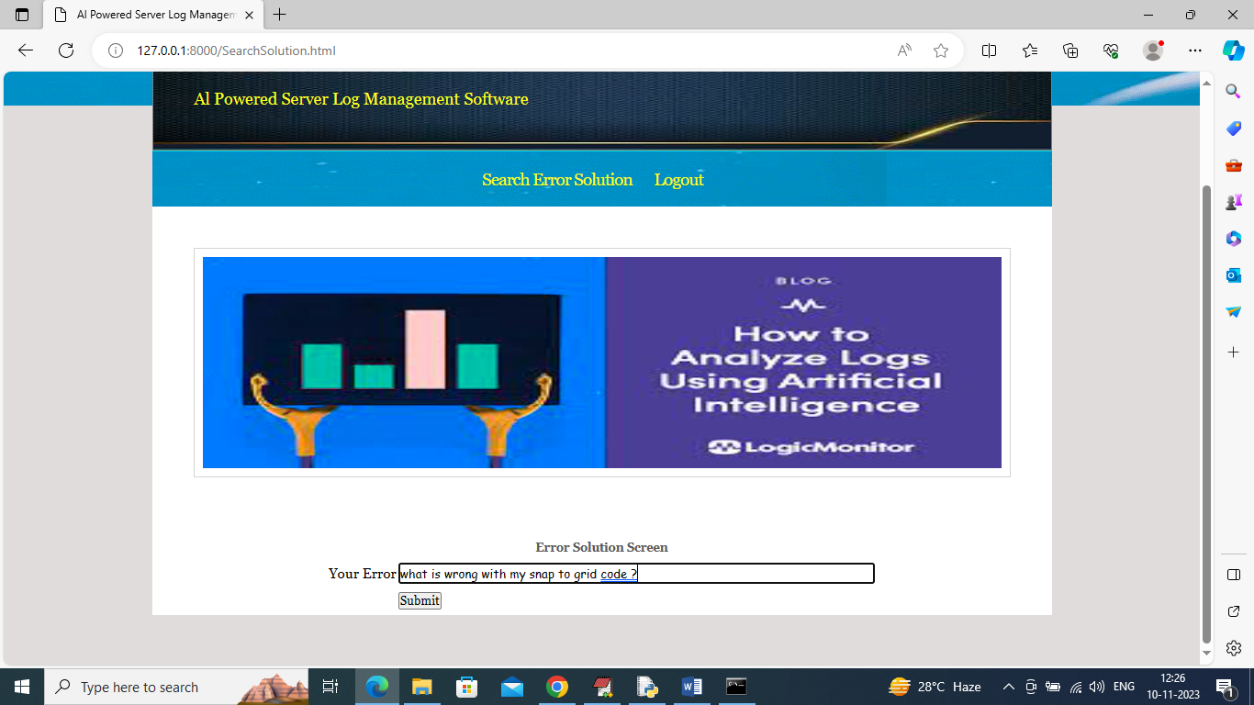

In above screen entering some other error and below is the output

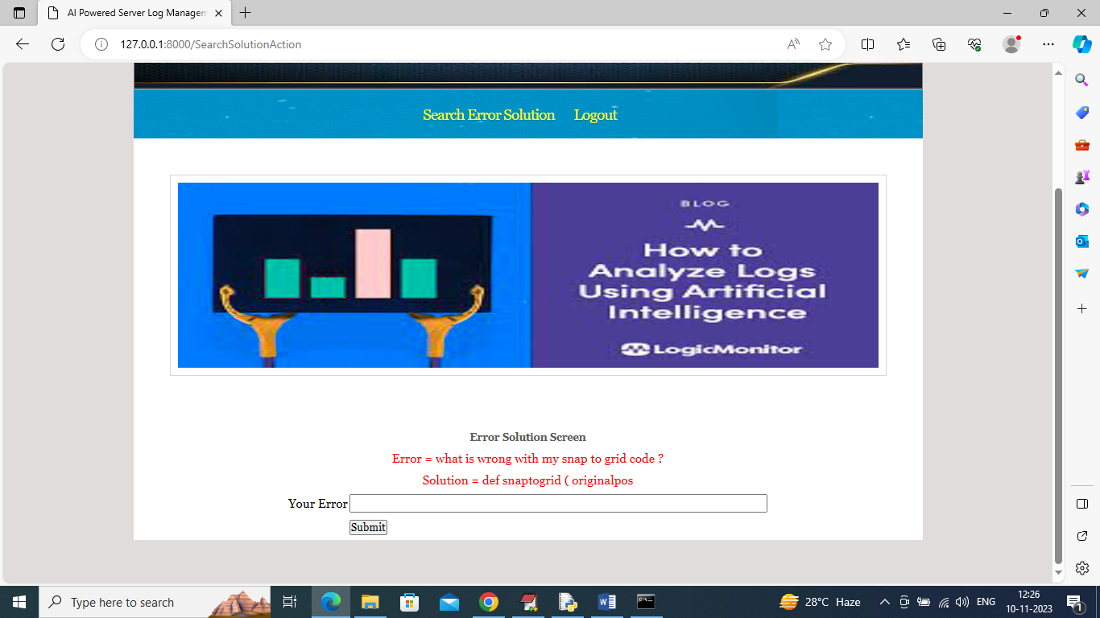

Similarly by following above screens you can ask any question from AI model to get solution